CS3002 Information Security
Assignment 2

- PKI Setup & Certificates
  - Root CA works; server & client certs issued.
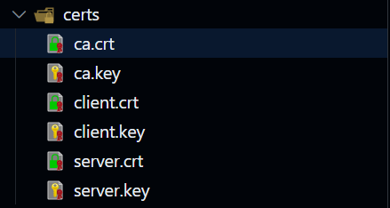
openssl x509 -in certs/ca.crt -text -noout
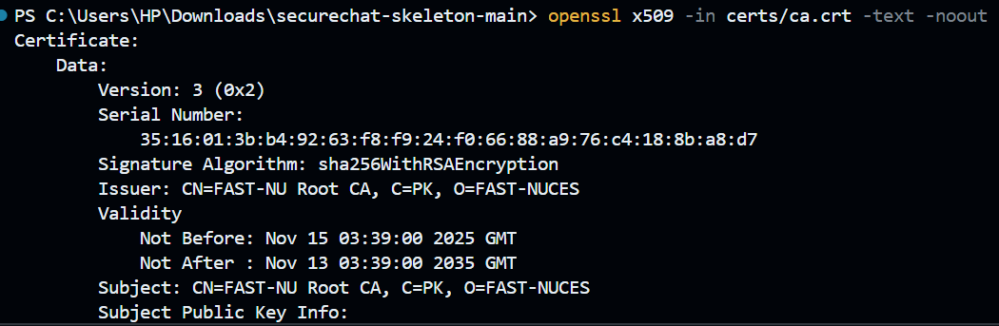

  - Mutual verification; expiry/hostname checks.
Checks are in pki.py
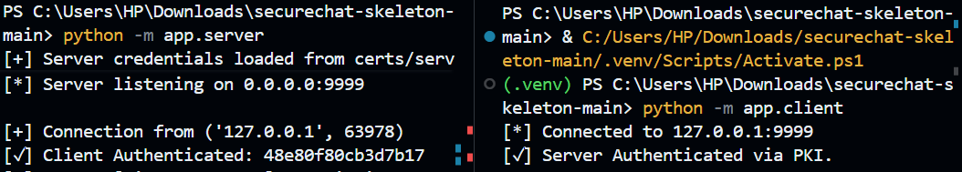

  - Invalid/self signed/expired certs rejected.
Invalid hostname here, rest checks are in code
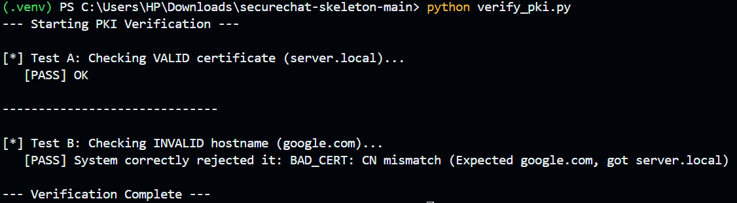

- Registration & Login Security
  - Per-user salt random ≥16B; store hex(sha256(salt||password)).
  - Credentials sent only after cert checks and under encryption.
  - No plaintext passwords in files/logs; constant-time compare.
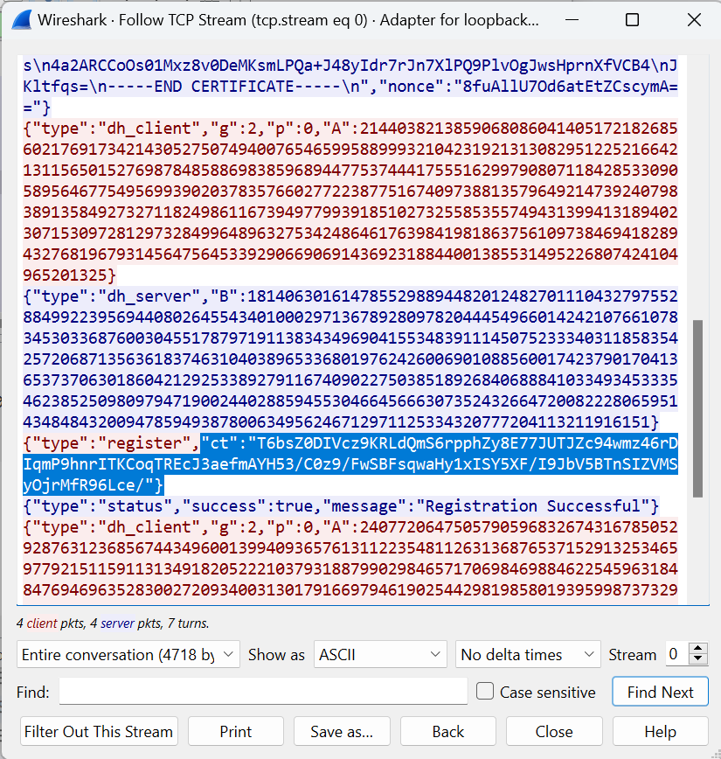

- Encrypted Chat (AES-128 only) block
  - DH after login; K = Trunc16(SHA256(Ks)).
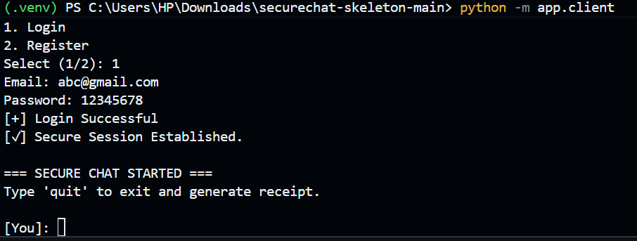

  - AES-128 used correctly with PKCS#7 padding.
  - Clean send/receive path; clear error handling.
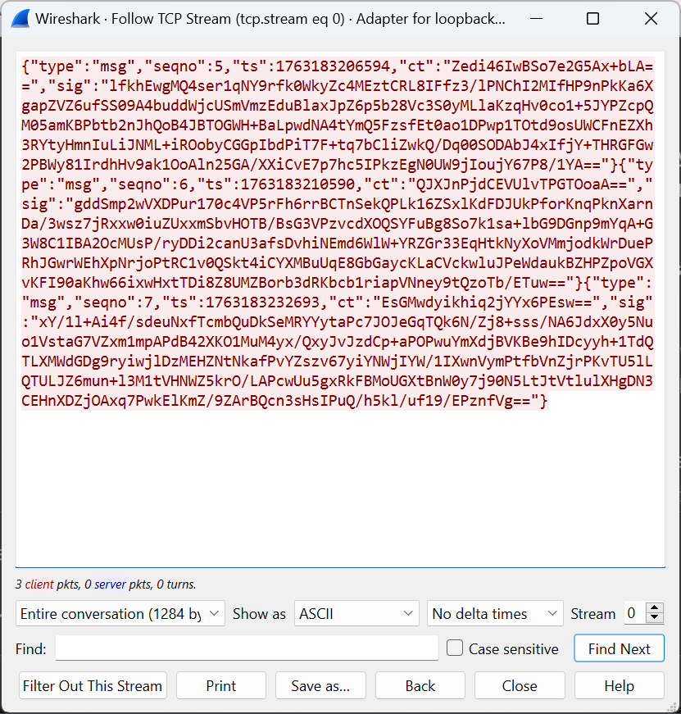
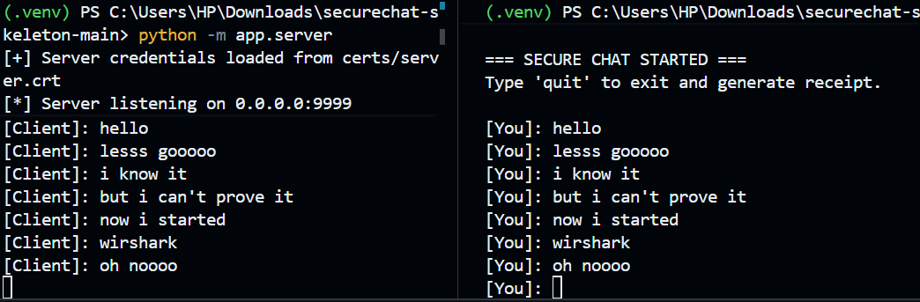
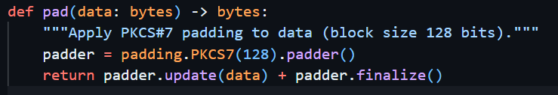

- Integrity, Authenticity & Non-Repudiation
